**Create recurring flows**

Create an Excel File

1. Create an Excel file named Bool.xlsx
2. Add columns
   1. First Name
   2. Last Name
   3. Contact Email
   4. Company Name
   5. Address
3. Add 5 set rows.
4. Save it

## Create a scheduled flow

1. Sign in to [Power Automate](https://ms.flow.microsoft.com/) by using your organizational account.
2. Select **My flows**.
3. Select **New**, and then select **Scheduled-from blank**.
4. Name your flow and under **Run this flow** set the flow to repeat every one Day.
5. Select **Create**.

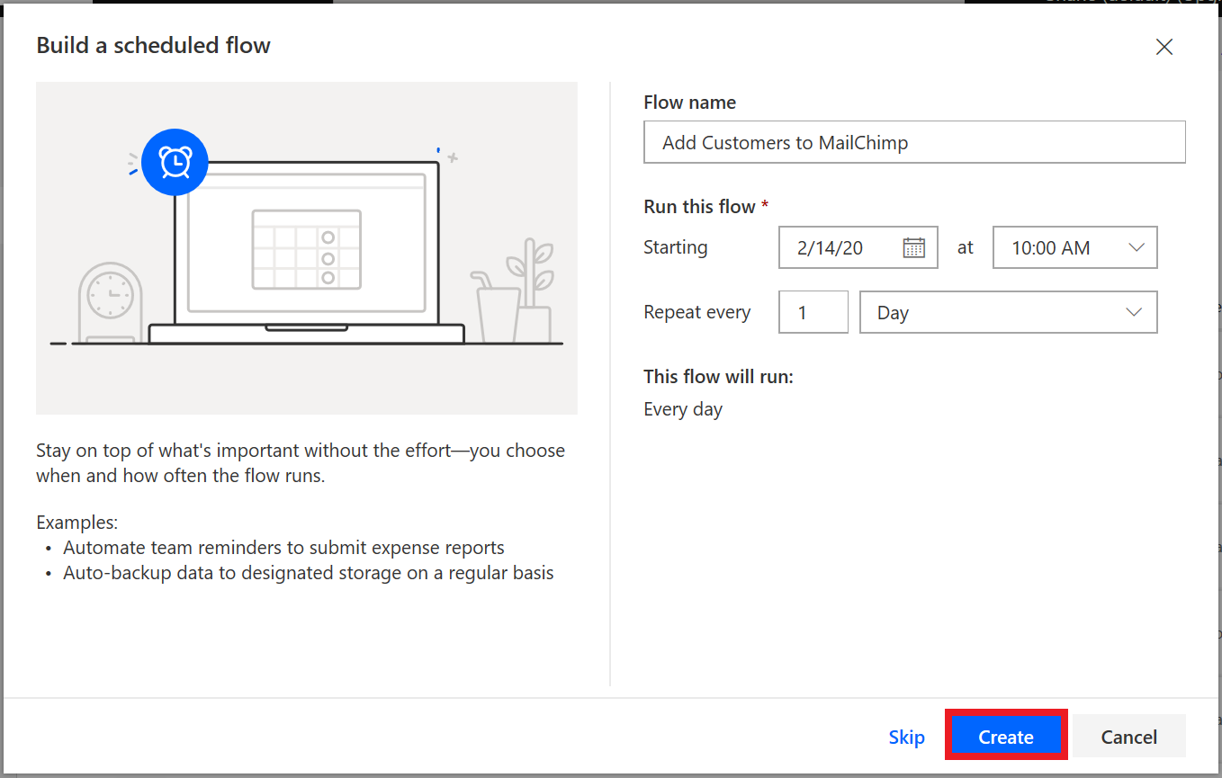

1. Select **New step**, to add an action.
2. In the search field, enter excel, select the **Excel Online (Business)** service, and then select the **List rows present in a table** action.
3. In the **File name** field, select the folder button, and then select the Excel file to use.
4. In the **Table name** box, select the drop-down arrow, and then browse to and select the worksheet to use.

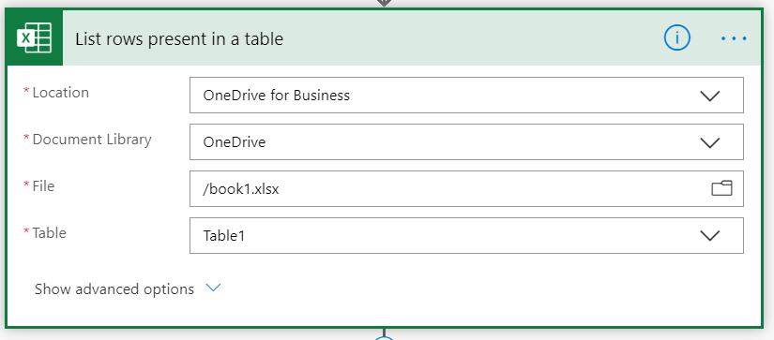

1. Select **New step**, and then select **Add an action**.
2. In the search field, enter chimp, select the **MailChimp** service, and then select the **MailChimp - Add member to list** action.

**Note**

MailChimp is a premium connector. Depending on your Power Automate license, you might need to sign up for a trial to use this connector.

1. In the **List Id** field, select the desired MailChimp mailing list. In the **Status** field, select subscribed.
2. In the **Email Address** field, use the dynamic content feature to add the **ContactEmail** field.

Notice that the flow automatically creates an additional step. Flow detects that you're setting up an action that requires an additional action. Whenever the flow reads a new email address, it will also create a new action for each row.

1. Use the dynamic content feature to fill in the **First name** and **Last name** fields.

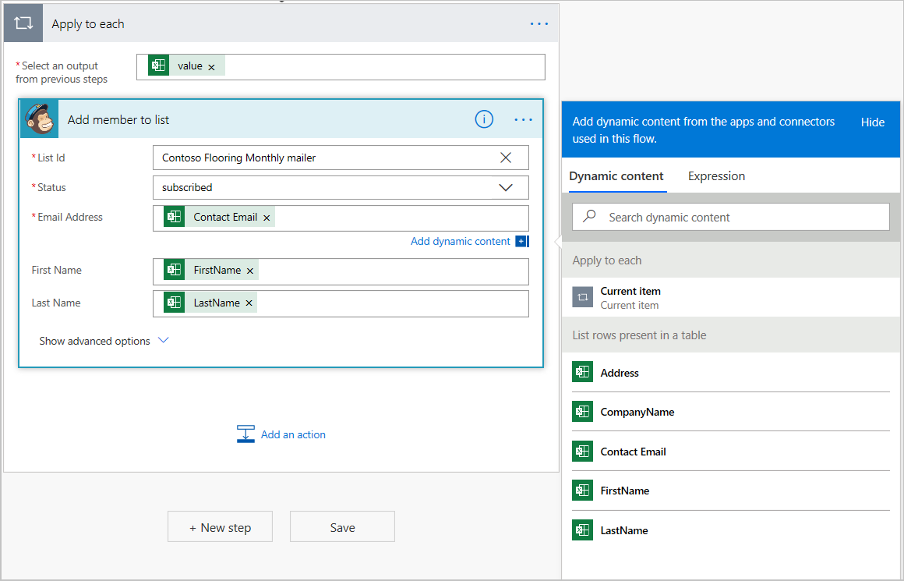

And there you have it!

This flow will now run once a day, get the new rows from the Excel worksheet, grab the email address and name from each row, and enter the email address and name in the Contoso MailChimp mail list, saving you both time and money.